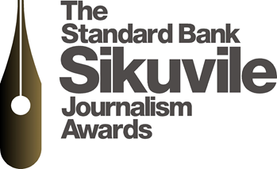

PRESS RELEASE
16 MARCH 2015
STANDARD BANK SIKUVILE JOURNALISM AWARDS 2015 DEADLINE FOR ENTRIES EXTENDED
The deadline for entries for the Standard Bank Sikuvile Journalism Awards 2015 has been extended from 18 March, Wednesday, to 20 March, Friday, 14h00.
The Awards, sponsored by Standard Bank, are open to all South African daily and weekly newspapers and online publications. This year the Awards provide an opportunity to define the values of the 20th century journalism, as we find ourselves in the midst of a media revolution.
You can also access the Entry Kit on our website, www.pdmedia.org.za.
PLEASE NOTE: Print and Digital Media SA has new offices and a new ADDRESS. Entries must be sent to Burnside Island Office Park, Building 8 – First Floor, 410 Jan Smuts, Craighall.
For any queries, please contact Malesedi Dlamini on malesedi@pdmedia.org.za


